FAKE NEWS DETECTION SYSTEM USING FEATURE BASED OPTIMISED MSVM CLASSIFICATION
Design and Implementation
Department of Computer Science and Engineering, [COLLEGE NAME]
Batch C6 (CSE-C) · Academic year [ACADEMIC YEAR]
Table 1: Project team
S.No. | Student name | Roll number
1 | Neela Mojes | 23K91A05H1
2 | Noor Saniya | 23K91A05H4
3 | Malkajgiri Akshitha | 23K91A05E2
4 | Maravajhala Radha Sri Aashritha | 23K91A05E7

Project guide: K Rajasekhar Rao
Chapter and section numbers quoted in the text (for example Chapter 8 or Section 6.2) refer to the full project report, 17.Final Document. Figures and tables in this document are numbered from 1.

1. DESIGN
This chapter describes how the detector is organised: its goals, architecture, data flow, main classes, stored data, core algorithm, modules and user interface. Every diagram was generated from the real code (backend/main.py, src/ and frontend/src/).

1.1 Design Goals
• One pipeline, one file. Vectoriser, scaler, PCA, mask, C, gamma and classifier are fitted and saved together, so training and prediction cannot disagree.
• A thin web layer. The API holds no model logic; it calls the library that the command-line scripts and the Streamlit application also use.
• Three honest verdicts with the probability of every class and the cue words noticed.
• Runs on a student laptop: CPU only, open-source packages, no data leaving the machine.
• Retrainable without restarting, and measured, not promised: the analytics screen reads every number from the loaded model and shows the baseline beside it.

1.2 System Architecture
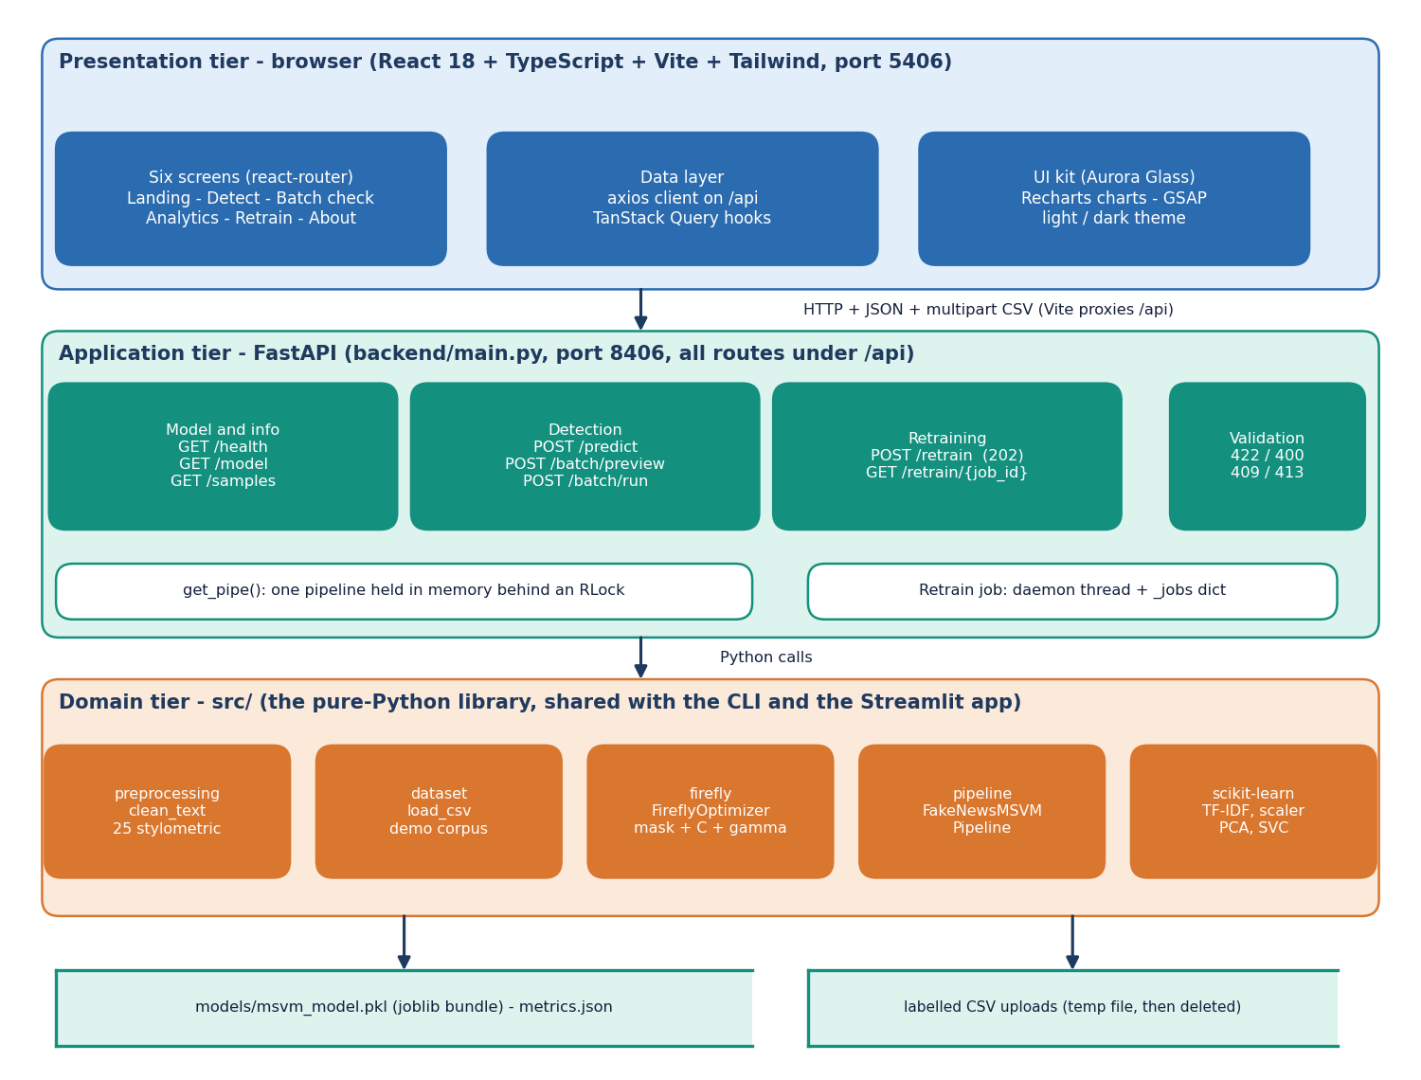
Figure 1: System architecture of TruthGlow: presentation, application and domain tiers over two file stores.
There are three tiers over two stores. The presentation tier is a React 18 and TypeScript application (Vite, Tailwind CSS, port 5406) with six screens and an axios client for /api. The application tier is a FastAPI service (backend/main.py, port 8406) with eight endpoints, one pipeline held in memory behind a re-entrant lock, and a background thread for retraining. The domain tier is the library src/ on scikit-learn. The stores are the joblib bundle models/msvm_model.pkl and the temporary file that holds an uploaded CSV while it is parsed. There is no SQL database and no user account. The Vite server proxies /api to port 8406 and the API also allows the two local origins on port 5406; both ports are set in .env.

1.3 High-Level Workflow
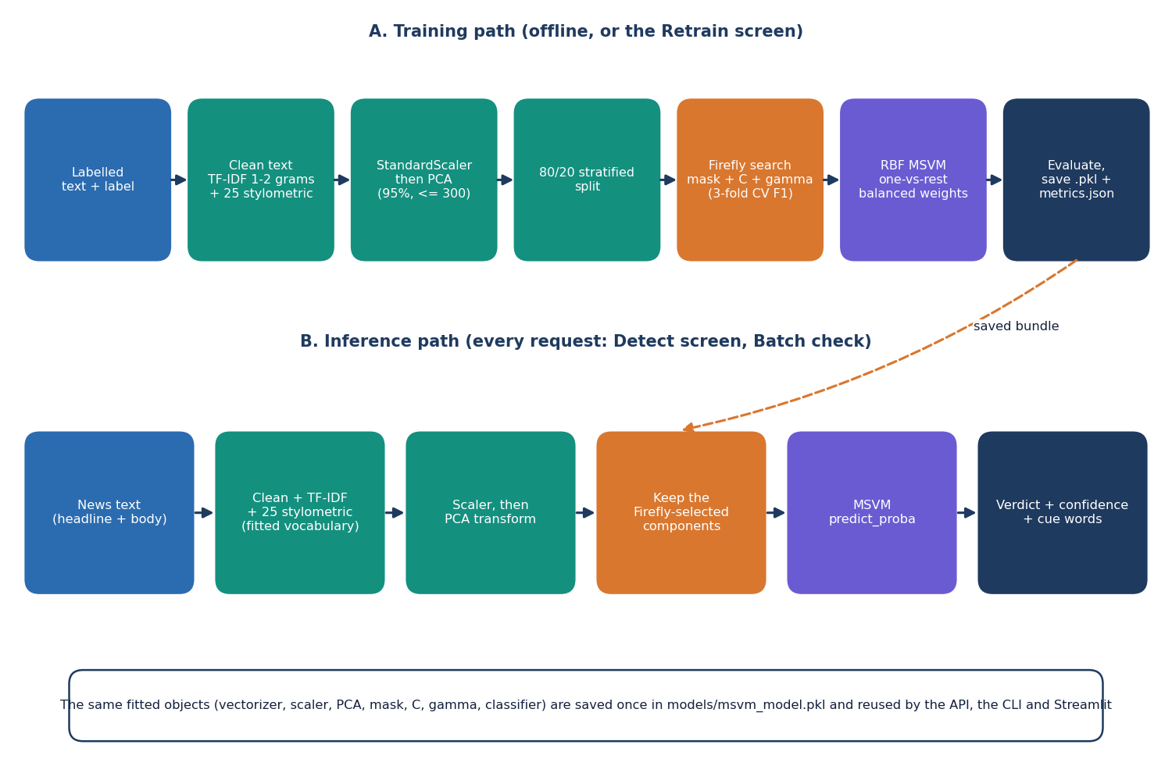
Figure 2: High-level workflow: the training path (offline or from the Retrain screen) and the inference path.
The training path cleans labelled text, builds TF-IDF and 25 stylometric features, standardises and reduces them with PCA, splits 80/20, lets the Firefly algorithm choose a subset of components with C and gamma, fits the RBF multi-class SVM with balanced class weights, evaluates and saves the bundle. The inference path applies the same fitted objects, keeps the selected components and asks the SVM for a class and probabilities.

1.4 Data Flow Diagrams
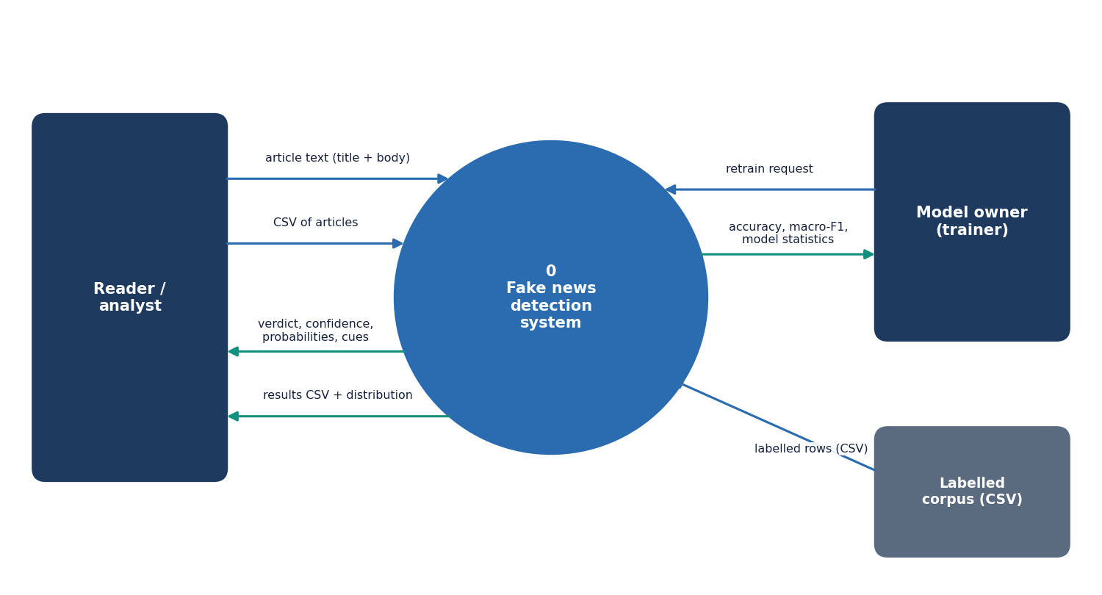
Figure 3: Level 0 data flow diagram: the system as one process with three external entities.
Level 0. The reader or analyst sends article text or a CSV and receives verdicts and results; the model owner sends a retrain request and receives accuracy, macro-F1 and statistics; a labelled CSV supplies training rows.
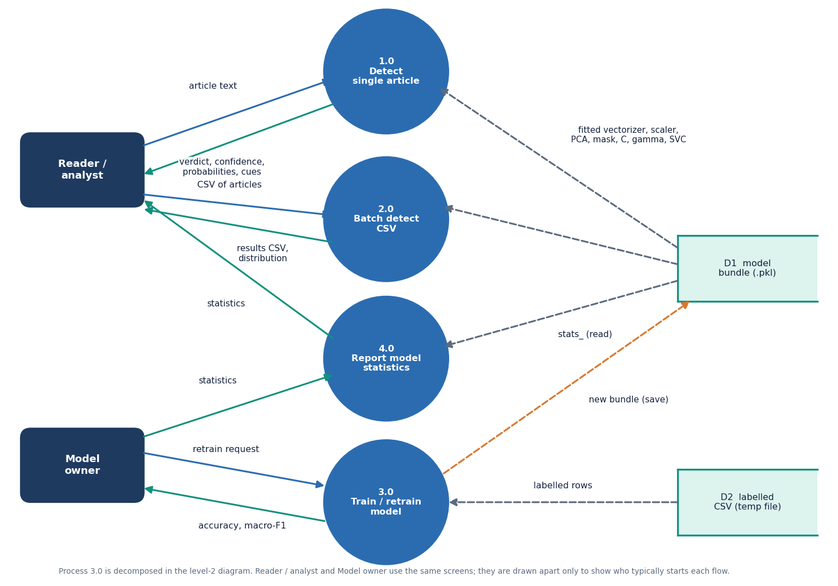
Figure 4: Level 1 data flow diagram: four processes and two data stores.
Level 1. Four processes: 1.0 Detect single article, 2.0 Batch detect CSV (both read the model bundle D1), 3.0 Train / retrain model (reads the temporary labelled CSV D2, writes D1) and 4.0 Report model statistics (reads the statistics inside D1).
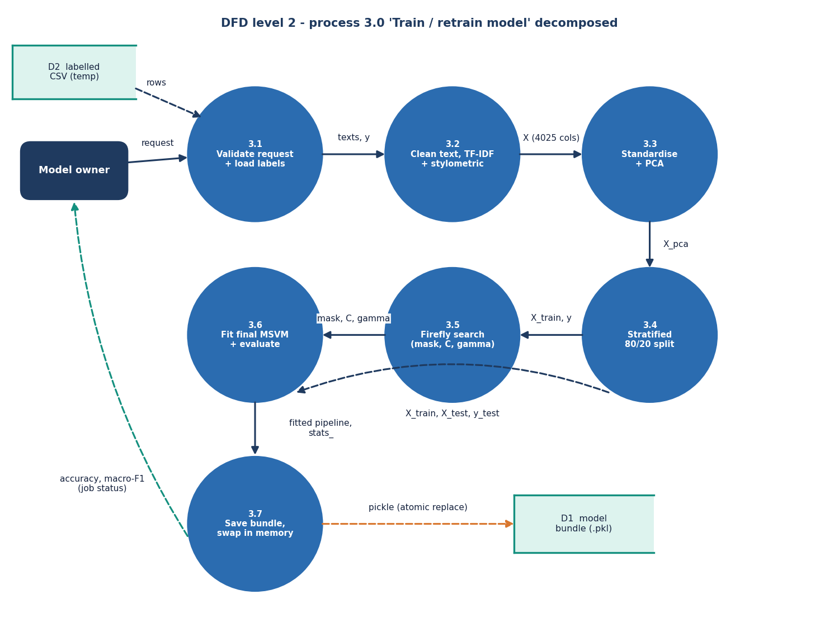
Figure 5: Level 2 data flow diagram: the seven steps inside process 3.0, Train / retrain model.
Level 2. Process 3.0 follows fit: 3.1 validate and load labels, 3.2 clean and featurise (4,025 columns), 3.3 standardise and PCA, 3.4 stratified 80/20 split, 3.5 Firefly search, 3.6 fit the final SVM and evaluate, 3.7 save the bundle, swap the in-memory pipeline under the lock and report the accuracy and macro-F1 as job status.

1.5 UML Diagrams
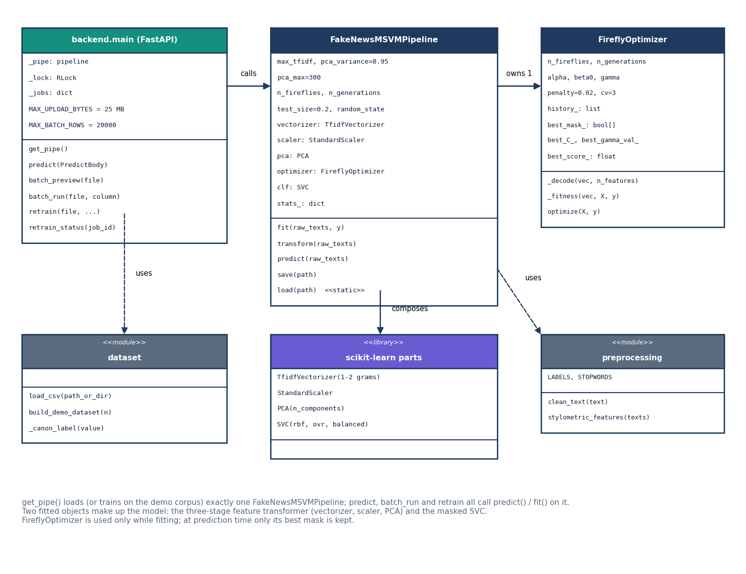
Figure 6: UML class diagram of the main classes and modules.
Class diagram. backend.main holds _pipe, _lock and _jobs and calls get_pipe(), which returns the one FakeNewsMSVMPipeline. The pipeline owns one FireflyOptimizer, composes the four scikit-learn parts and uses the preprocessing module; the backend uses the dataset module. The optimiser is needed only while fitting; at prediction time only its best mask, C and gamma are kept.
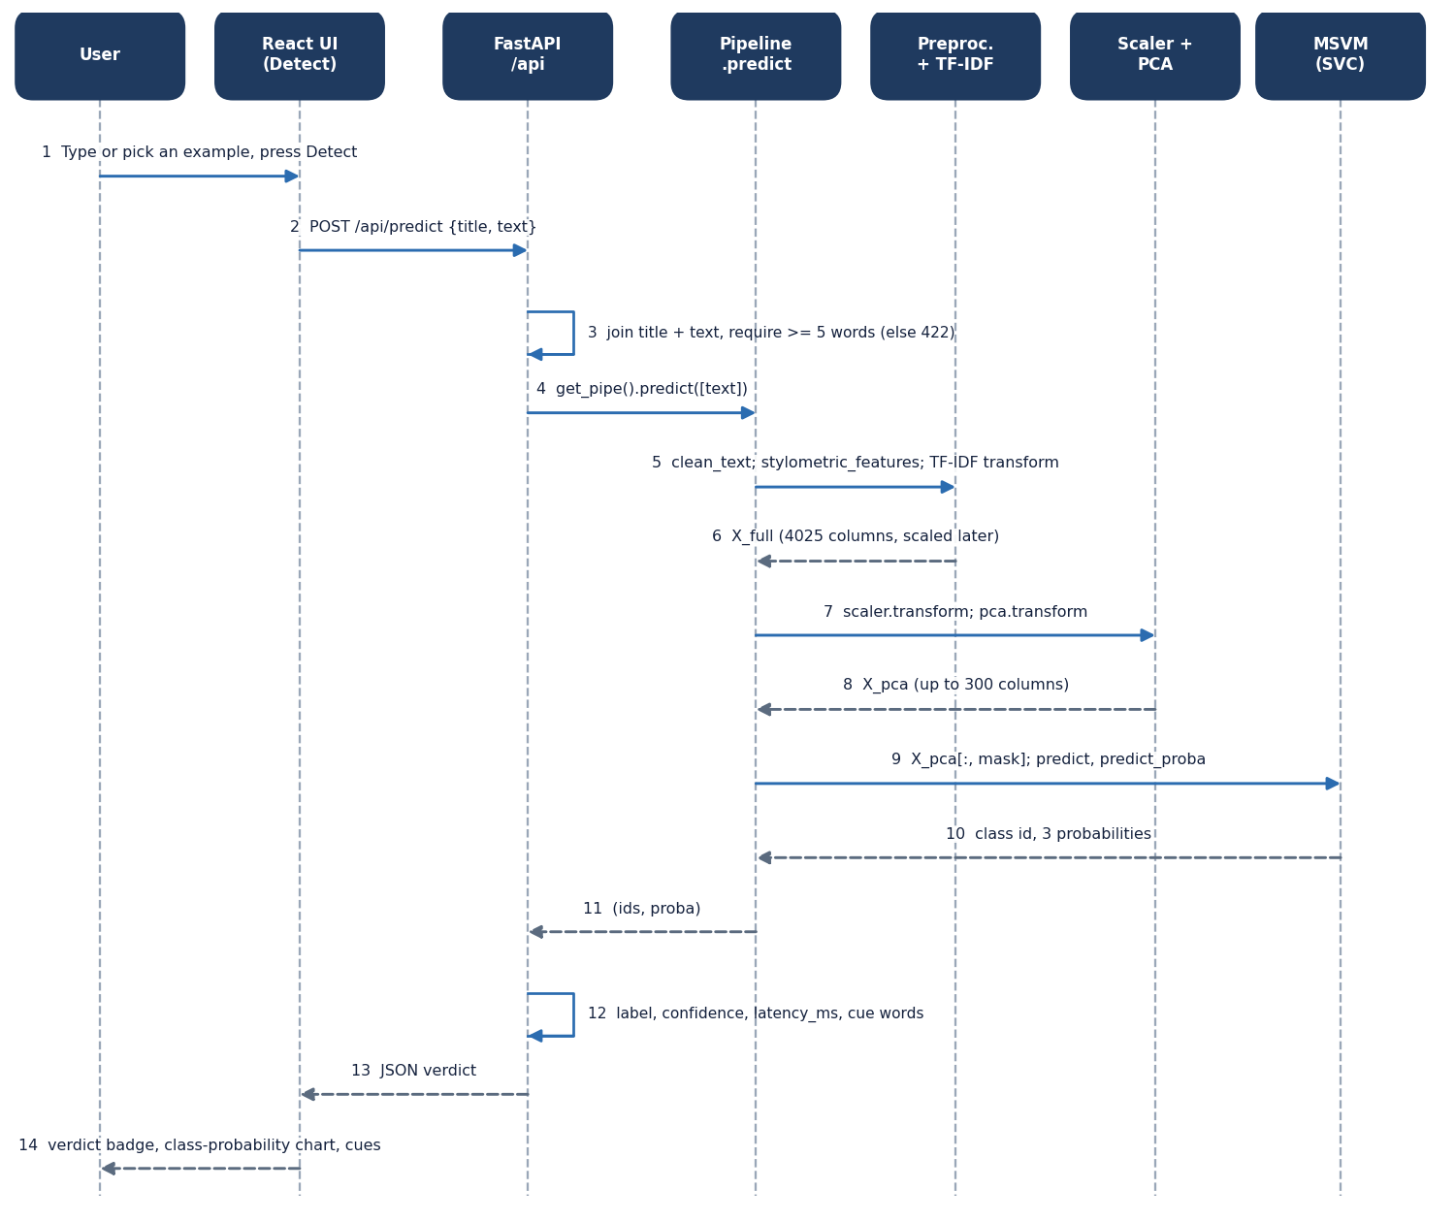
Figure 7: Sequence diagram of one detection request, from the Detect screen to the SVM and back.
Sequence: one detection. The page posts {title, text} to /api/predict; the backend rejects fewer than five words (422), asks the pipeline to predict, which cleans, featurises, scales, projects, masks and queries the SVM; the backend adds the confidence (largest probability), latency and cue words. Measured on the development machine: 3.7 ms mean inside the server and a median of 6.5 ms for the HTTP round trip.
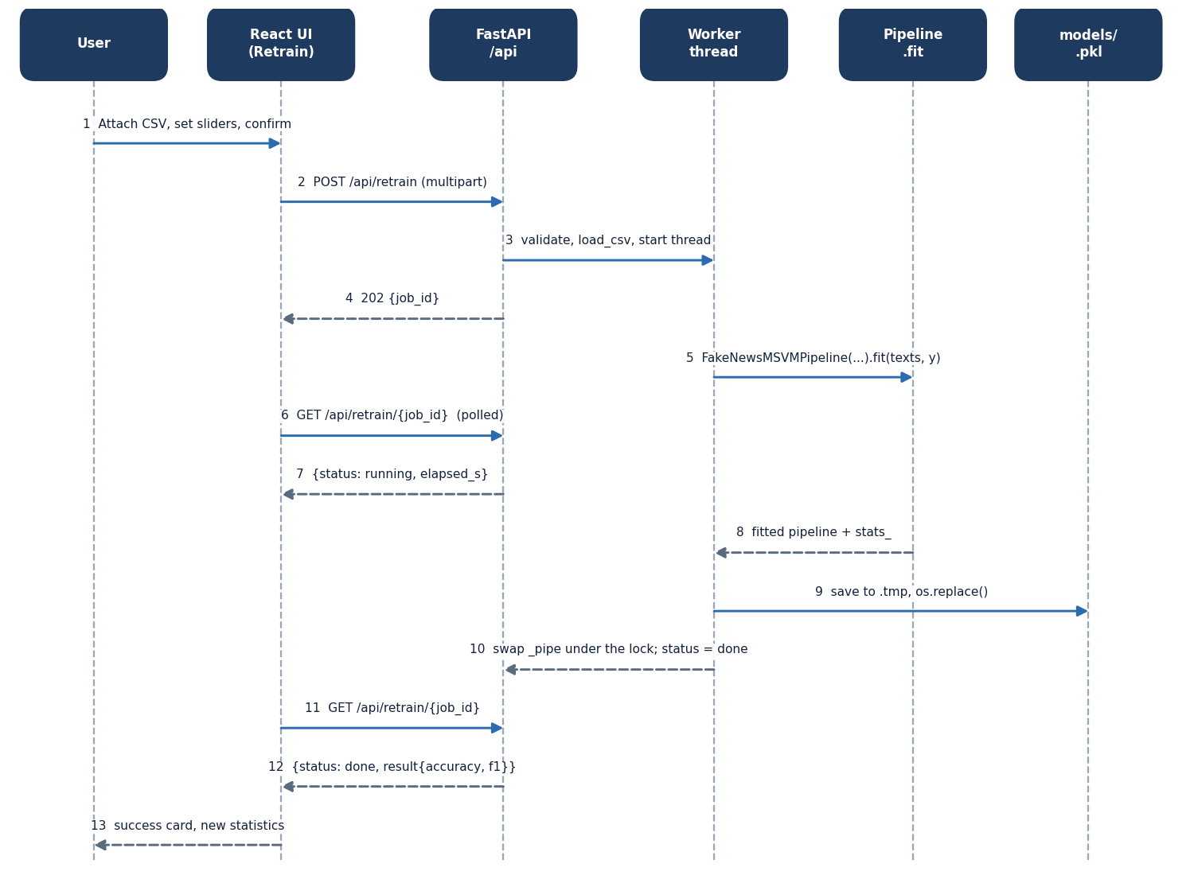
Figure 8: Sequence diagram of retraining: upload, background job, polling and hot swap.
Sequence: retraining. /api/retrain validates the request, starts a daemon thread and answers 202 with a job id; the page polls every two seconds (the id is kept in local storage so a reload resumes). The thread fits a new pipeline, saves it to a .tmp file, renames it over the model file, swaps the in-memory pipeline under the lock and marks the job done. On failure the previous model stays in use.
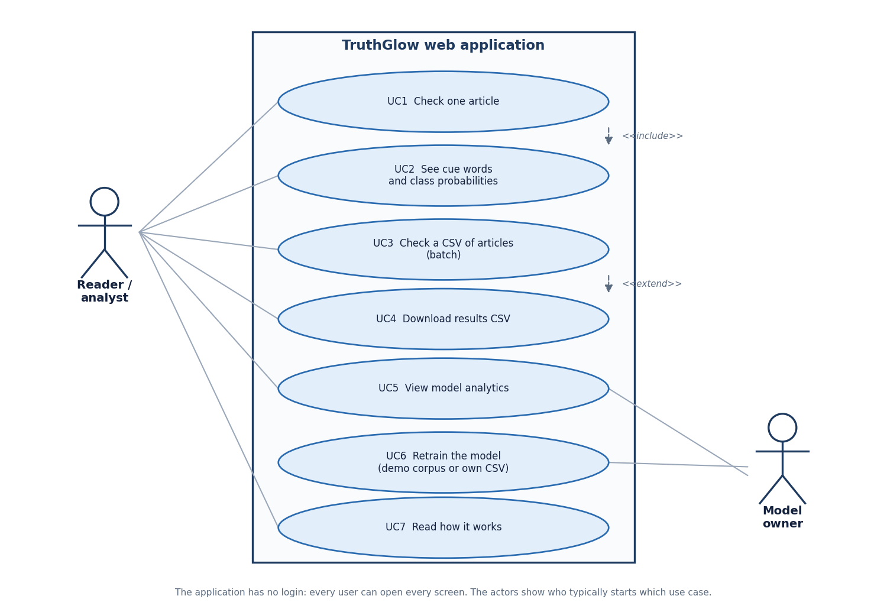
Figure 9: Use case diagram: seven use cases and two actors.
Use cases. The reader checks one article (UC1, including cues and probabilities UC2), checks a CSV (UC3, with download UC4), views analytics (UC5) and reads how it works (UC7); the model owner retrains (UC6) and views analytics. There is no login.

1.6 Data Design
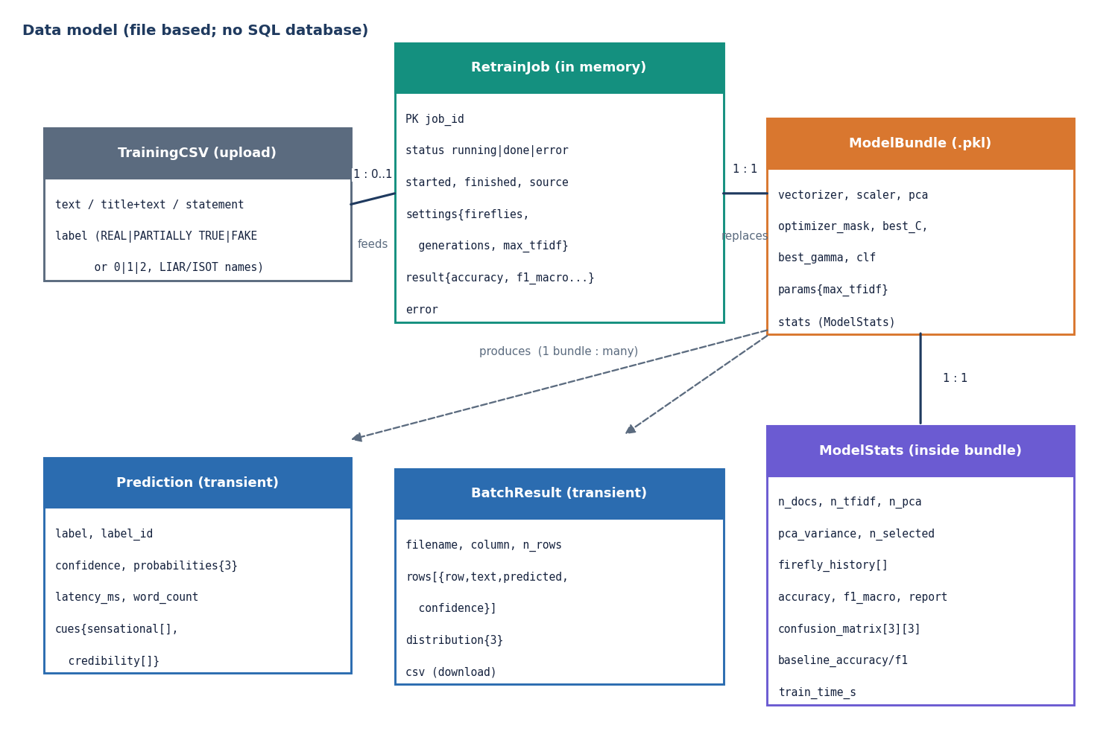
Figure 10: Entity-relationship diagram of the data model; the product has no SQL database.
The product has no SQL database because it keeps no records; the diagram shows the file and in-memory data model. A TrainingCSV feeds at most one RetrainJob (in memory, 12-character id); a finished job replaces the single ModelBundle, which contains its ModelStats; one bundle produces many Predictions and BatchResults, which are never stored.
Table 2: Persistent and transient data
Item | Where | Lifetime and content
Model bundle | models/msvm_model.pkl (joblib dictionary) | Until the next retrain: vectorizer, scaler, pca, optimizer_mask, best_C, best_gamma, clf, stats, params
Model statistics | Inside the bundle | n_docs, feature counts, n_pca, pca_variance, n_selected, firefly_history, accuracy, f1_macro, report, confusion_matrix, baseline scores, training time; y_test and y_pred are removed by /api/model
Retrain job | _jobs in the API process | Until restart: status, times, source, settings, result or error
Uploaded CSV | Temporary file | Deleted once parsed; text (or title + text, statement, news, content) and label

Two bundles exist: the shipped demo bundle (0.81 MB, 750 synthetic documents) and models/liar2_msvm_model.pkl (12.0 MB, trained on 3,000 real statements). Labels in a CSV may be REAL, PARTIALLY TRUE, FAKE, the numbers 0, 1, 2, or LIAR names (true and mostly-true become REAL, half-true PARTIALLY TRUE, barely-true, false and pants-fire FAKE).

1.7 Algorithm Design
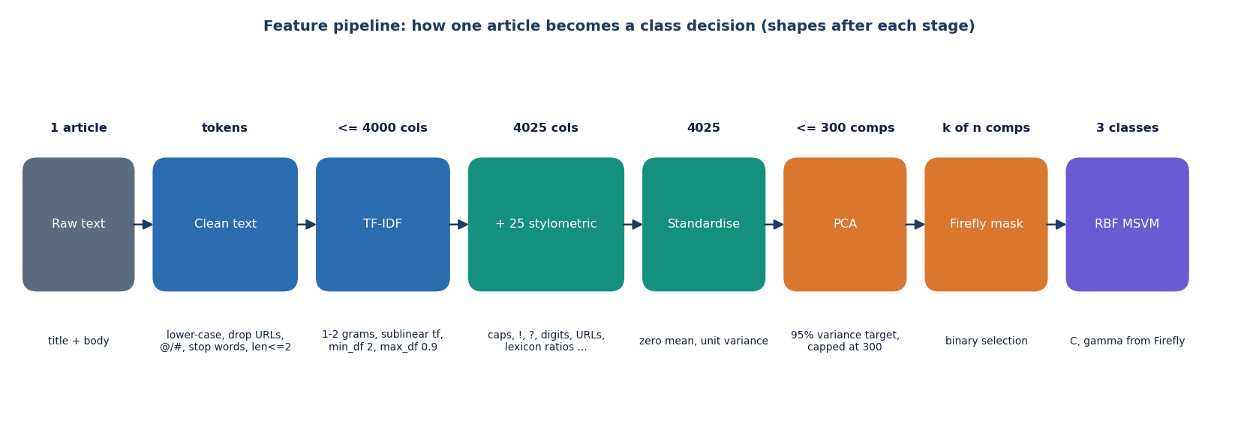
Figure 11: Feature pipeline: the shape of one article's representation after each stage.
One article becomes up to 4,000 TF-IDF values (1-2 grams, sublinear tf, min_df 2, max_df 0.9) joined to 25 stylometric values. After standardisation PCA keeps components for 95 % of the variance, capped at 300; the Firefly mask keeps a subset; the RBF SVM decides. On real statements the cap is always reached and keeps only 29.3% of the variance; on the demo corpus 95 % needs 136 components.
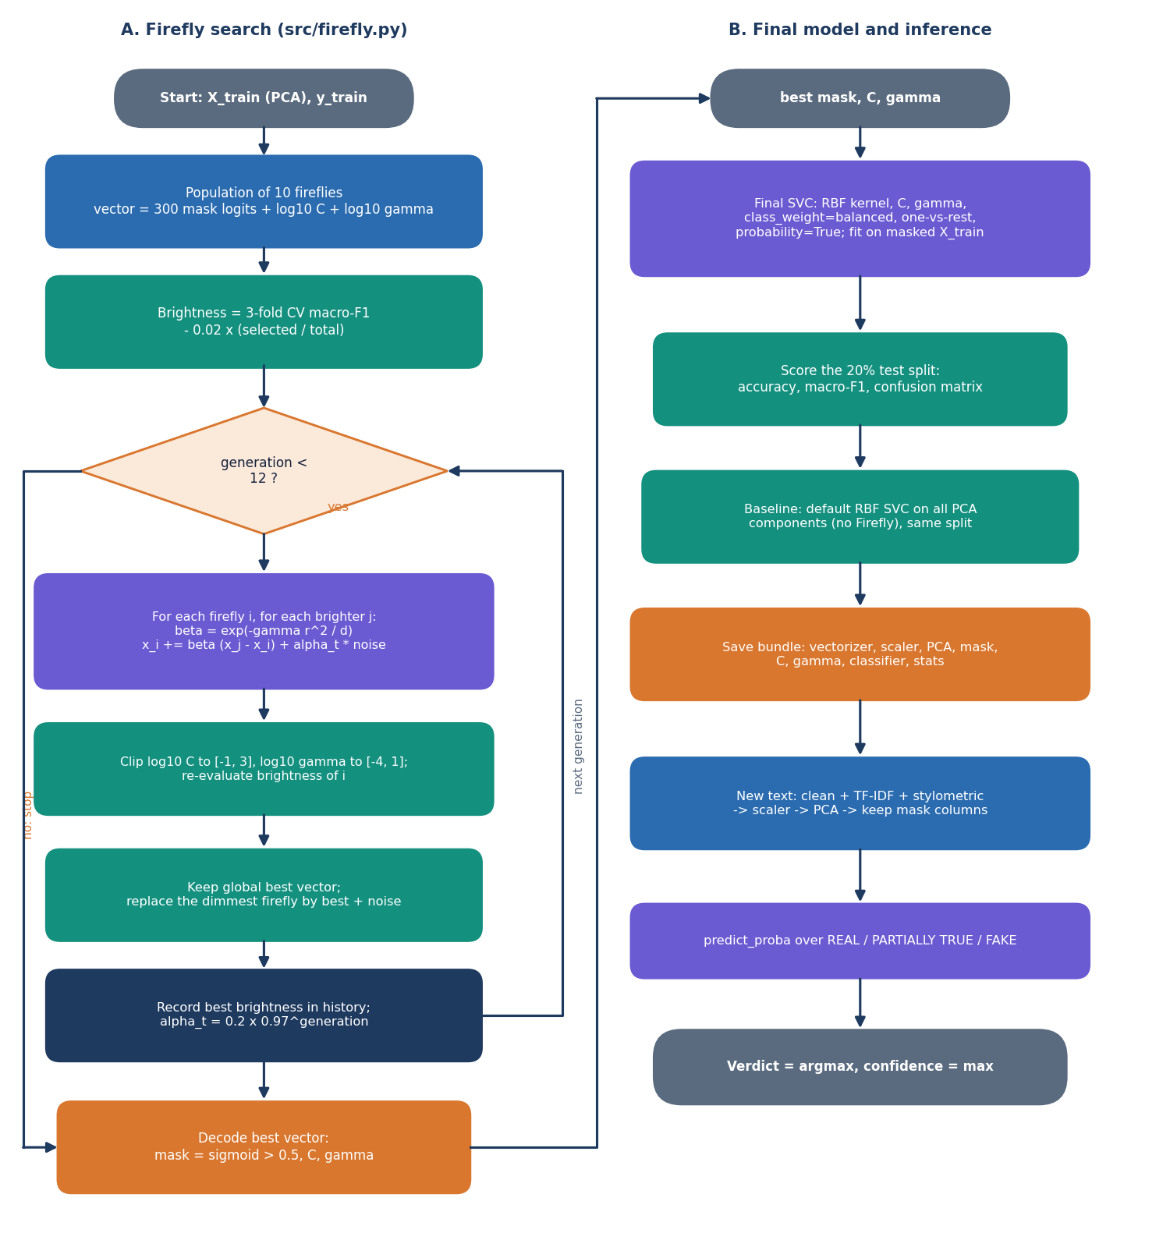
Figure 12: Flowchart of the core algorithm: (A) the Firefly search and (B) the final model and inference.
Encoding. A firefly has k + 2 entries: one logit per PCA component (kept when sigmoid exceeds 0.5; one is forced on if none is), log10 C in [-1, 3] and log10 gamma in [-4, 1]. Fitness. Mean macro-F1 of a three-fold stratified cross-validation of SVC(rbf, class_weight='balanced') on the masked data, minus 0.02 times the share of components kept; macro-F1 is used because FAKE is the largest class and accuracy would reward majority guessing. Movement. Attractiveness is beta0 exp(-gamma r^2 / length) with beta0 = gamma = 1; noise alpha starts at 0.2 and decays by 0.97 per generation; after each generation the dimmest firefly is replaced by the best vector plus noise. Ten fireflies and twelve generations are the defaults.

1.8 Module Design
Table 3: Modules and their responsibilities
Module | Lines | Main contents
src/preprocessing.py | 91 | clean_text; stylometric_features (25 values: lengths, ratios of unique, stop, capitalised, long and short words, punctuation, digits, URLs, first person, superlatives and three lexicon scores); LABELS
src/dataset.py | 110 | load_csv (file or folder; LIAR and ISOT layouts); build_demo_dataset (synthetic template corpus)
src/firefly.py | 106 | FireflyOptimizer: _decode, _fitness, optimize
src/pipeline.py | 181 | FakeNewsMSVMPipeline: fit, transform, predict, save, load; statistics and baseline
backend/main.py | 339 | Eight endpoints, get_pipe(), _cues() (13 sensational and 8 credibility words), _read_csv_upload(), one validation handler; status codes 422, 400, 413, 409, 404
frontend/src/pages/ | 1,303 | Landing, Detect, Batch, Analytics, Retrain, About, NotFound; each a lazily loaded chunk
frontend/src/components, lib | - | Aurora Glass kit (AppShell, Card, Button, Field, Slider, Table, FileDrop, Toast, charts, motion), api.ts, queries.ts, verdict.ts, theme.tsx

Server state is handled by TanStack Query: model information is cached for 60 seconds, the examples for the session, the API health is polled every 20 seconds and a retraining job every 2 seconds while it runs.

1.9 User Interface Design
The interface follows the Aurora Glass kit: translucent cards over a dark aurora background with a light theme remembered in the browser. The application screens share one shell: a collapsible sidebar (a drawer on narrow screens), a top bar with a live "Model online" indicator and the theme toggle. Colour is never the only signal: each verdict has its own icon and word, and every field has a label, hint and error sentence.
Table 4: Screens
Route | Screen | Main elements
/ | Landing | Hero with live demo verdict, technology strip, metric strip, how it works, feature cards
/app | Detect | Headline and text fields (five words needed, Ctrl+Enter), examples, verdict badge, confidence bar, probability chart, cue lists
/app/batch | Batch check | CSV drop zone, ten-row preview, column selector, summary cards, distribution chart, sortable table (first 50 rows), results download
/app/analytics | Model analytics | Stat cards, what the optimisation did, confusion matrix, Firefly curve, classification report, baseline against proposed
/app/retrain | Retrain | Optional labelled CSV, sliders (fireflies 4-20, generations 3-30, TF-IDF 1,000-8,000), confirm dialog, progress and success cards
/app/about | About | Pipeline steps, output classes, loaded model read live, how to run

  Figure 13: Detect screen with a real LIAR2 test statement entered. | 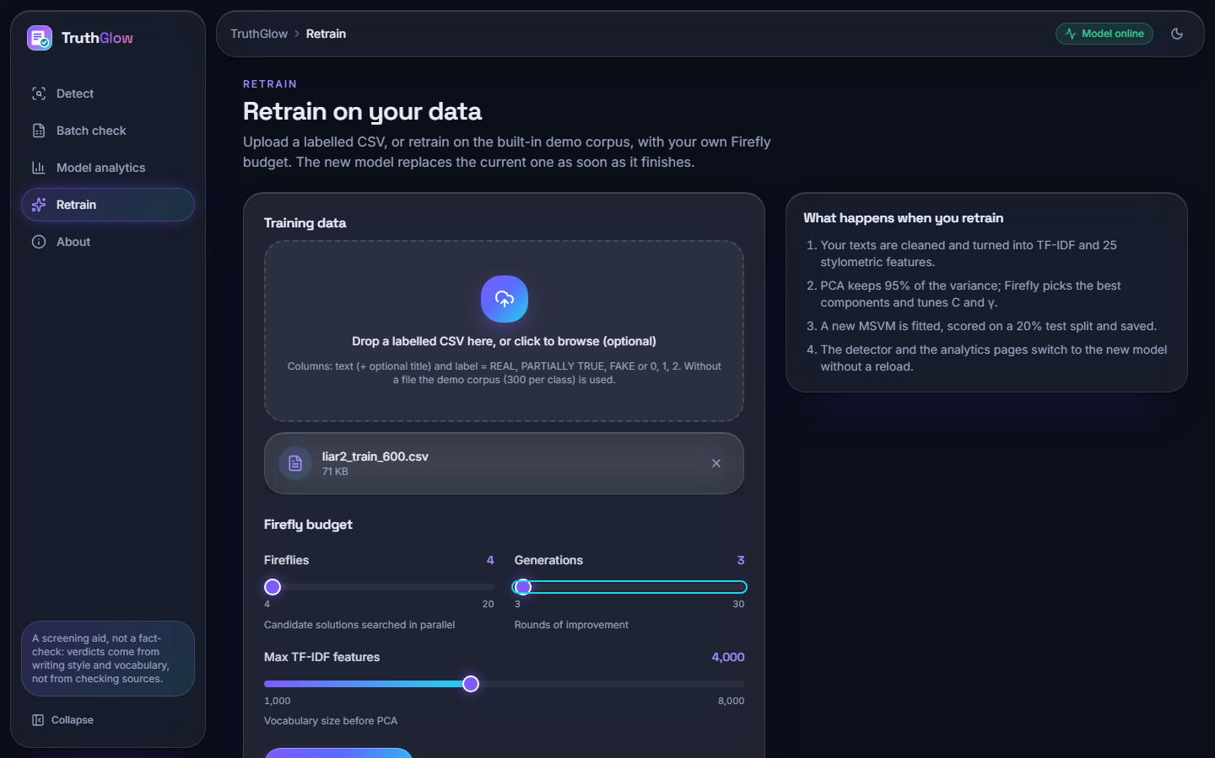  Figure 14: Retrain screen with a 600-row labelled CSV attached.

The results of each screen, produced by the model trained on real data, are shown and discussed in Chapter 8.

1.10 Design Decisions and Their Consequences
Table 5: Design decisions
Decision | Reason | Consequence
Thin API over the library | One code path for web, CLI and Streamlit | A fix in src/ reaches all front ends
One model in memory behind a lock | Prediction costs 3.7 ms; loading takes seconds | Retraining swaps the object under the lock
Everything in one joblib file | Keeps fitted parts consistent | 12.0 MB real-data bundle; needs the scikit-learn version that wrote it (1.9)
Retraining as a polled background thread | Training takes minutes; browsers time out | Job state is lost on restart; the page then reports an unknown job
Atomic replacement of the model file | A failed run leaves the previous model usable | Retraining overwrites the shipped model unless FAKENEWS_MODEL points elsewhere
PCA capped at 300 components | Bounds search space and SVM cost | Only 29.3% of the variance is kept on real text
Class weights and macro-F1 fitness | Real data is unbalanced | Accuracy falls below the majority-class rate (0.576) while macro-F1 rises
SVC(probability=True) for probabilities | Per-class probabilities with no extra code | Verdict and largest probability disagree on 48.8% of real test statements (found in testing)
No login or database | Local single-user tool; privacy by default | No audit trail; anyone who can reach the port can retrain
Results CSV returned in the batch response | Simple, nothing stored | Limit 20,000 rows and 25 MB; 2,296 rows took 1.2 s

The design favours a system that can be run, inspected and measured over a large one. The cost shows in the missing stemming step, the single-user assumption and the in-memory job table; none affects the correctness of a verdict, but each limits deployment.

2. IMPLEMENTATION

2.1 Application architecture
The product has a three-tier structure and keeps every earlier entry point working. The library src/ (preprocessing 91 lines, dataset 110, Firefly 106, pipeline 181) contains all model logic and has no web dependency. The API layer backend/main.py (339 lines, FastAPI) is a thin wrapper: every endpoint calls the same pipeline functions that the command line and the Streamlit app call, and no model logic lives in it. The web interface frontend/ (React 18, TypeScript, Vite, Tailwind CSS; about 4,900 lines, of which the six page components are 1,300) talks to the API through one axios client on /api, proxied by the Vite server so no port is hard-coded in the browser code. The older entry points train.py, predict.py and app.py (Streamlit) remain and use the same model file.
Table 6: Main files
File or folder | Role
src/preprocessing.py | clean_text, stylometric_features, stop words, class labels
src/dataset.py | load_csv (CSV, ISOT and LIAR layouts), build_demo_dataset
src/firefly.py | FireflyOptimizer: decode, fitness, optimise
src/pipeline.py | FakeNewsMSVMPipeline: fit, transform, predict, save, load
backend/main.py | FastAPI application, endpoints, validation, retraining job
frontend/src/pages/ | Landing, Detect, Batch, Analytics, Retrain, About, NotFound
models/ | msvm_model.pkl (demo model), liar2_msvm_model.pkl, metrics.json
scripts/, run.bat | Tests, experiments, measurement and document builders; one-click launcher (ports 8406 and 5406)

Model state. The API holds exactly one fitted pipeline in memory (get_pipe), protected by a re-entrant lock. It is loaded from the path in the environment variable FAKENEWS_MODEL (default models/msvm_model.pkl) when the server starts; if the file does not exist the server trains a small demo model on the synthetic corpus (250 documents per class, 8 fireflies, 8 generations) and saves it. Loading takes 6.1 s for the 12.6 MB LIAR2 model and 2.8 s for the 0.85 MB demo model, measured from process start to the first successful health check.
Retraining. POST /api/retrain validates the request, reads the optional CSV into texts and labels, creates a job record and starts a daemon thread that fits a new pipeline, writes it to a temporary file and replaces the model file with os.replace, then swaps the in-memory pipeline under the lock. The browser polls GET /api/retrain/{job_id} every 2 seconds. Only one job may run at a time. While training runs, /api/predict keeps using the old model, so detection never stops.

2.2 API design
All routes are under /api and exchange JSON (uploads use multipart form data). The interactive OpenAPI documentation is served at /docs by FastAPI.
Table 7: Endpoints
Method and path | Request | Response | Errors
GET /api/health | - | status, model_loaded, model_path | -
GET /api/model | - | labels, stats (accuracy, macro-F1, PCA and Firefly facts, confusion matrix, report, baseline; the raw test predictions are removed), pipeline steps | -
GET /api/samples | - | Six real documents from the demo corpus, two per class | -
POST /api/predict | JSON {title, text} | label, label_id, confidence, probabilities, latency_ms, word_count, cues{sensational, credibility} | 422 if fewer than 5 words
POST /api/batch/preview | multipart file (.csv) | filename, n_rows, columns, guessed_column, first 10 rows | 400 not a CSV, empty, unreadable; 413 over 25 MB
POST /api/batch/run | multipart file, column | n_rows, seconds, rows[{row, text, predicted, confidence}], distribution, csv | 400 bad column; 413 over 20,000 rows or 25 MB
POST /api/retrain | multipart optional file, fireflies, generations, max_tfidf | 202 {job_id} | 422 out of range; 400 bad CSV or under 30 rows; 409 a job is running
GET /api/retrain/{job_id} | - | status running / done / error, elapsed_s, source, settings, result or error | 404 unknown job (also after a restart)

The cue words returned by /api/predict come from two fixed lists in the backend: 13 sensational words (shocking, secret, unbelievable, miracle, hoax, conspiracy, exposed, urgent, breaking, viral, click, banned, hidden) and 8 credibility words (official, confirmed, verified, evidence, report, data, expert, audit). They only illustrate the verdict, and on real statements they rarely match.

2.3 Security and error handling
The application is a local tool without accounts, so security work is limited to input validation and safe handling of files. What exists, and what does not, is stated below.
Table 8: Validation and safety measures
Concern | Measure
Upload type, size and rows | More than 20,000 rows or 25 MB gives 413; only .csv names accepted; empty or unreadable files are rejected with 400
Free-text input | A statement needs at least five words (title and text joined) or the API answers 422; the browser shows the same rule before sending
Parameter ranges | Fireflies 4-20, generations 3-30, max TF-IDF 1,000-8,000; otherwise 422
Concurrent retraining | A second retraining request while one runs gets 409; the job store is a dictionary guarded by the single-job rule
Uploaded training data | Written to a temporary file that is deleted in a finally block after parsing; fewer than 30 rows or an unknown label column gives 400
Model file integrity | A new model is written to <model>.tmp and moved into place with os.replace, so a crash cannot leave a half-written model; the live pipeline is swapped under a lock
Cross-origin access | CORS allows only http://localhost:5406 and http://127.0.0.1:5406
Output encoding | The React interface renders text through JSX, which escapes HTML; a test confirms that script tags in an article do not break /api/predict
Privacy | Rows are read by the local backend only and are not stored

Not implemented: authentication, authorisation, rate limiting, HTTPS, audit logging, and any protection of the model file against replacement by the Retrain screen (it overwrites the file by design, and the interface asks for confirmation first). Pickle files can execute code when loaded, so a model file must come from a trusted source; loading a model pickled with a different scikit-learn version may fail, so run.bat installs the version the shipped model needs. These gaps are acceptable for a local demonstration and would have to be closed before any multi-user deployment.

2.4 Installation and execution
The measurements were made on: Intel Core i5-12500 (6 cores, 12 threads, 3.0 GHz), 15.7 GB RAM, Windows 11 Pro, no GPU used. Python 3.11 or newer and Node.js 20 or newer are required.

2.4.1 One-click start
1. Double-click run.bat. It checks that Python and Node.js are installed.
2. It builds .venv (and rebuilds it if a copy from another computer does not run) and installs backend/requirements.txt (scikit-learn, pandas, NumPy, SciPy, joblib, FastAPI, uvicorn, python-multipart).
3. It runs npm install in frontend/ on the first start.
4. It starts the backend on port 8406, waits until /api/health answers, then starts the frontend on port 5406 and opens http://localhost:5406.
5. Closing the two minimised windows stops the servers.

2.4.2 By hand
python -m venv .venv
.venv\Scripts\python -m pip install -r backend/requirements.txt
.venv\Scripts\python -m uvicorn backend.main:app --port 8406

cd frontend
npm install
npm run dev # http://localhost:5406

2.4.3 Command line, Streamlit and checks
python train.py # demo corpus, writes models/msvm_model.pkl and metrics.json
python train.py --csv data/my.csv --fireflies 10 --generations 12 --max-tfidf 4000
python predict.py --text "Official report confirmed by experts with verified data"
streamlit run app.py # the original interface

python scripts/smoke_test.py # API end to end on a copy of the model
python scripts/unit_edge_tests.py # library and edge-case tests
cd frontend && npm run build # type-check and production build

A training CSV needs a text column (and optionally title) and a label column holding REAL, PARTIALLY TRUE, FAKE, the numbers 0, 1, 2, or LIAR's word labels. Numeric six-way LIAR2 ids must be converted to the three class names first, because load_csv reads the numbers 0, 1 and 2 as the project's classes directly. Retraining from the Retrain screen replaces models/msvm_model.pkl; keep a copy to return to the shipped model. To reproduce the real-data results: download the three LIAR2 CSV files into data/liar2/, run scripts/run_experiments.py --seed 42 (and 7, 2024) with the project's Python, then scripts/docs_build/make_figures.py.

3. KEY CODE WALK-THROUGHS
This section walks through the code that matters most, quoting the repository as it was when the results of this report were measured.

3.1 Cleaning the text
clean_text lower-cases the text, removes URLs, mentions and hashtags, drops everything that is not a letter, then removes stop words and tokens of two characters or fewer. What remains is a space-separated string of content words that TF-IDF can use. No stemming is done (limitation L9).
def clean_text(text: str) -> str:
if not isinstance(text, str):
return ""
t = text.lower()
t = _URL.sub(" ", t)
t = _MENTION.sub(" ", t)
t = t.replace("\n", " ")
t = _NON_ALPHA.sub(" ", t)
t = _WS.sub(" ", t).strip()
tokens = [w for w in t.split() if w not in STOPWORDS and len(w) > 2]
return " ".join(tokens)

3.2 Building the feature matrix and reducing it
The first part of fit builds the TF-IDF matrix (word unigrams and bigrams, sublinear term frequency, terms in at least two and at most 90 % of the documents), appends the 25 stylometric columns, standardises every column and fits a full PCA only to find how many components reach 95 % of the variance. The number is then limited to 300 (and to fewer than the number of documents), and a PCA with that many components is fitted. On the LIAR2 subsample the cap always applies.
def fit(self, raw_texts, y, verbose=True):
t0 = time.time()
y = np.asarray(y)
cleaned = [clean_text(t) for t in raw_texts]
if verbose:
print(f"[1/5] Cleaned {len(cleaned)} docs")

self.vectorizer = TfidfVectorizer(max_features=self.max_tfidf,
ngram_range=(1, 2),
sublinear_tf=True,
min_df=2, max_df=0.9)
X_tfidf = self.vectorizer.fit_transform(cleaned)
X_style = stylometric_features(raw_texts)
X_full = hstack([X_tfidf, csr_matrix(X_style)]).toarray()
n_tfidf = X_tfidf.shape[1]
if verbose:
print(f"[2/5] Features: TF-IDF={n_tfidf} + stylometric=25 "
f"-> total {X_full.shape[1]}")

self.scaler = StandardScaler()
X_scaled = self.scaler.fit_transform(X_full)

# PCA — cap components for speed, keep target variance
pca_full = PCA(random_state=self.random_state)
pca_full.fit(X_scaled)
cumvar = np.cumsum(pca_full.explained_variance_ratio_)
n_keep = int(np.searchsorted(cumvar, self.pca_variance) + 1)
n_keep = max(10, min(n_keep, self.pca_max, X_scaled.shape[0] - 1,
X_scaled.shape[1]))
self.pca = PCA(n_components=n_keep, random_state=self.random_state)

3.3 The Firefly search
A firefly is a vector of 302 numbers: 300 logits that become a component mask when their sigmoid exceeds 0.5, then log10 C and log10 gamma. _decode turns a vector into a mask and the two parameters and never returns an empty mask. _fitness is the 3-fold cross-validated macro-F1 of an RBF SVM with balanced class weights on the masked features, minus 0.02 times the share of components kept. In optimize, every firefly moves towards each brighter one by an attractiveness that decays with the squared distance, plus a random step whose size shrinks by 3 % per generation; the dimmest firefly is replaced by the best vector plus noise at the end of each generation (elitism), and the best brightness is stored for the convergence curve.
def _decode(self, vec, n_features):
n = n_features
mask_sig = 1.0 / (1.0 + np.exp(-vec[:n]))
mask = mask_sig > 0.5
if mask.sum() == 0:
mask[np.argmax(mask_sig)] = True
logC = float(np.clip(vec[n], -1, 3))
logG = float(np.clip(vec[n + 1], -4, 1))
return mask, 10 ** logC, 10 ** logG

def _fitness(self, vec, X, y):
n_features = X.shape[1]
mask, C, g = self._decode(vec, n_features)
if mask.sum() < 2:
return 0.0
clf = SVC(C=C, gamma=g, kernel="rbf", class_weight="balanced",
decision_function_shape="ovr")
cv = StratifiedKFold(n_splits=self.cv, shuffle=True,
random_state=self.random_state)
try:
scores = cross_val_score(clf, X[:, mask], y, cv=cv,
scoring="f1_macro", n_jobs=-1)
f1 = float(np.mean(scores))
except Exception:
return 0.0
return f1 - self.penalty * (mask.sum() / n_features)

def optimize(self, X, y, verbose=False):
rng = np.random.default_rng(self.random_state)
n_features = X.shape[1]
dim = n_features + 2
# init population: sigmoid-friendly range + hyperparams
pop = rng.uniform(-1, 1, size=(self.n_fireflies, dim))
pop[:, n_features] = rng.uniform(-1, 2, size=self.n_fireflies) # logC
pop[:, n_features + 1] = rng.uniform(-3, 0, size=self.n_fireflies) # logG
brightness = np.array([self._fitness(v, X, y) for v in pop])

best_idx = int(np.argmax(brightness))
self.best_score_ = float(brightness[best_idx])
best_vec = pop[best_idx].copy()

for gen in range(self.n_generations):
alpha_t = self.alpha * (0.97 ** gen) # decay randomness
for i in range(self.n_fireflies):
for j in range(self.n_fireflies):
if brightness[j] > brightness[i]:
r2 = float(np.sum((pop[i] - pop[j]) ** 2))
beta = self.beta0 * np.exp(-self.gamma * r2 / dim)
step = alpha_t * (rng.random(dim) - 0.5) * 2.0
pop[i] = pop[i] + beta * (pop[j] - pop[i]) + step
# keep hyperparam dims in range
pop[i][n_features] = np.clip(pop[i][n_features], -1, 3)
pop[i][n_features + 1] = np.clip(pop[i][n_features + 1], -4, 1)
brightness[i] = self._fitness(pop[i], X, y)
cur_best = int(np.argmax(brightness))
if brightness[cur_best] > self.best_score_:
self.best_score_ = float(brightness[cur_best])
best_vec = pop[cur_best].copy()
# elitist random walk of worst firefly
worst = int(np.argmin(brightness))
pop[worst] = best_vec + alpha_t * (rng.random(dim) - 0.5)
brightness[worst] = self._fitness(pop[worst], X, y)
self.history_.append(float(np.max(brightness)))
if verbose:
print(f" [Firefly] gen {gen+1}/{self.n_generations} "
f"best={self.best_score_:.4f}")

mask, C, g = self._decode(best_vec, n_features)
self.best_mask_ = mask
self.best_C_ = float(C)
self.best_gamma_val_ = float(g)
self.best_gamma_ = float(g)
return self

3.4 The final classifier and the baseline
The mask and the two parameters found by the search define the final SVM. It is fitted on the training part, scored on the 20 % hold-out, and a default SVM on all components is fitted beside it to fill the baseline row of the Analytics screen. probability=True makes scikit-learn fit a Platt scaling by internal cross-validation, which is the source of the probabilities discussed in limitation L6.
# Final MSVM (multi-class SVC, OvR, balanced weights)
self.clf = SVC(C=self.optimizer.best_C_,
gamma=self.optimizer.best_gamma_val_,
kernel="rbf", class_weight="balanced",
decision_function_shape="ovr", probability=True,
random_state=self.random_state)
self.clf.fit(Xtr[:, mask], ytr)

# Evaluate + baselines
t_train = time.time() - t0
pred = self.clf.predict(Xte[:, mask])
acc = accuracy_score(yte, pred)
f1m = f1_score(yte, pred, average="macro")
# baseline: plain SVM on PCA (no firefly) for the report table
base = SVC(class_weight="balanced", decision_function_shape="ovr",
random_state=self.random_state)
t_b = time.time()
base.fit(Xtr, ytr)
t_b = time.time() - t_b
bpred = base.predict(Xte)

3.5 The prediction endpoint
The endpoint joins the headline and the text, rejects anything under five words (HTTP 422), takes the pipeline from get_pipe() and measures only the model call for latency_ms. The verdict is the predicted class, the probabilities come from predict_proba, and the confidence is their maximum.
@app.post("/api/predict")
def predict(body: PredictBody):
full = (body.title + " " + body.text).strip()
if len(full.split()) < 5:
raise HTTPException(422, "Please enter at least a few words of news text (5 or more).")
pipe = get_pipe()
t0 = time.time()
ids, proba = pipe.predict([full])
latency_ms = (time.time() - t0) * 1000
label_id = int(ids[0])
result = {
"label": ID2LABEL[label_id],
"label_id": label_id,
"latency_ms": round(latency_ms, 1),
"cues": _cues(full),
"word_count": len(full.split()),
"confidence": None,
"probabilities": None,
}
if proba is not None:
probs = proba[0]
result["probabilities"] = {ID2LABEL[i]: float(p) for i, p in enumerate(probs)}
result["confidence"] = float(np.max(probs))
return result

3.6 Retraining on a background thread
The retrain endpoint validates the sliders and the upload, starts a daemon thread and answers 202 with a job id at once. The worker fits a new pipeline, writes it to a temporary file, replaces the model file atomically with os.replace and swaps the in-memory pipeline under a lock, so that requests served during the swap see either the old or the new model and never a partial one.
def _retrain_worker(job_id, texts, y, fireflies, generations, max_tfidf):
job = _jobs[job_id]
try:
new_pipe = FakeNewsMSVMPipeline(max_tfidf=max_tfidf, n_fireflies=fireflies, n_generations=generations)
new_pipe.fit(texts, y, verbose=False)
os.makedirs(os.path.dirname(MODEL_PATH), exist_ok=True)
tmp = MODEL_PATH + ".tmp"
new_pipe.save(tmp)
os.replace(tmp, MODEL_PATH)
global _pipe
with _lock:
_pipe = new_pipe
s = new_pipe.stats_
job["result"] = {
"accuracy": s["accuracy"], "f1_macro": s["f1_macro"], "n_docs": s["n_docs"],
"n_selected": s["n_selected"], "n_pca": s["n_pca"], "train_time_s": s["train_time_s"],
}
job["status"] = "done"
except Exception as exc:
job["error"] = f"Training failed: {exc}"
job["status"] = "error"
finally:
job["finished"] = time.time()

3.7 The equal-budget random search
The experiment script counts the number of fitness evaluations that the Firefly search used and gives random search the same number, using the same fitness function and the same initial ranges. This is what makes the comparison in Chapter 8 fair.
# ---- equal-budget random search with the same fitness function
rs = FireflyOptimizer(n_fireflies=a.fireflies, n_generations=a.generations, random_state=a.seed)
rng = np.random.default_rng(a.seed + 1)
nf = Xtr.shape[1]
best, best_vec = -1, None
t2 = time.time()
for _ in range(res["n_firefly_evals"]):
v = rng.uniform(-1, 1, size=nf + 2)
v[nf] = rng.uniform(-1, 3)
v[nf + 1] = rng.uniform(-4, 1)
f = rs._fitness(v, Xtr, ytr)
if f > best:
best, best_vec = f, v.copy()
m_r, C_r, g_r = rs._decode(best_vec, nf)
rsvc = SVC(C=C_r, gamma=g_r, class_weight="balanced", random_state=a.seed).fit(Xtr[:, m_r], ytr)
res["random_search"] = {"fitness": float(best), "n_selected": int(m_r.sum()), "C": float(C_r), "gamma": float(g_r),
"search_time_s": time.time() - t2, "test": score(te_y, rsvc.predict(Xte[:, m_r]))}

4. IMPLEMENTATION DECISIONS AND THEIR REASONS
Table 9: Implementation decisions and their reasons
Decision | Reason | What was observed
Keep the model code a pure-Python library (src/) and add a thin FastAPI layer | The CLI, the Streamlit app and the web app then share one tested pipeline | No model logic is duplicated; 33 API edge checks run against the same code
TF-IDF with 1-2 grams plus 25 stylometric features | Cheap, interpretable, no GPU; stylometric signals such as capital letters and exclamation marks are classic fake-news cues [21] | On real statements the TF-IDF linear models do at least as well, so the features are adequate but not the limit
Standardise all columns before PCA | PCA is sensitive to scale; stylometric counts and TF-IDF weights differ by orders of magnitude | Standardising sparse TF-IDF columns gives rare terms the same variance as common ones; whether this hurts was not tested
PCA to 95 % variance, capped at 300 components | A cap keeps the Firefly search space and the SVM fits affordable | On real text the cap is always reached and keeps 29.3 % of the variance (L5)
One Firefly vector for the mask, log C and log gamma | Features and parameters interact, so a joint search avoids tuning them in two steps | About 148 of 300 components are kept; no gain on the test split over defaults
Penalise the share of components kept (0.02) | Prefer smaller feature sets at equal score | The penalty is small; the mask-only variant scored lower than the default SVM
Fitness: 3-fold macro-F1 inside the training part | Macro-F1 does not reward ignoring the minority classes; 3 folds keep each evaluation cheap | Training-split fitness is higher for Firefly than for random search (0.433 against 0.426); test scores are equal within noise
Balanced class weights | The FAKE class is 58 % of the test split; the idea follows the base paper's class weighting [1, 15] | Macro-F1 well above the majority baseline; accuracy below it
probability=True on the SVC | The interface needs class probabilities for the chart and the confidence | Platt probabilities ignore the class weights and disagree with the verdict on 49 % of the statements (L6)
Retraining on a daemon thread with atomic file replacement | A request must not time out for minutes, and a crash must not leave a half-written model | The Retrain screen polls the job; the tests and the screen captures retrained a copy of the model, so the shipped file was not touched
Limits: 25 MB per upload, 20,000 rows per batch, 5 words minimum | Protect the single local process from oversized and empty input | Covered by edge-case tests (413 and 422 responses)
No login and no database | A local, single-user teaching application; the original product had neither | Simplest to run; unsuitable for shared deployment (L12)
Experiments on LIAR2, three seeds, a 3,000-statement subsample | A real, public, licensed benchmark; the Firefly search is the cost driver | About 8 min per fit; full-data results not measured (L7)

